19 A program that: -Uses efficient data structures to compute numerology -numbers for names. -Stores and organises results in a structured way. -Analyses frequency and patterns in numerology data.
#include <stdio.h>
#include <stdlib.h>
#include <string.h>
#include <ctype.h>

// Node structure for linked list
typedef struct Node {
char name[50];
int numerologyNumber;
struct Node* next;
} Node;

// Function to create a new node
Node* createNode(const char* name, int number) {
Node* newNode = (Node*) malloc(sizeof(Node));
if (!newNode) {
printf("Memory allocation failed!\n");
exit(1);
}
strcpy(newNode->name, name);
newNode->numerologyNumber = number;
newNode->next = NULL;
return newNode;
}

// Insert at end
void insertAtEnd(Node** head, const char* name, int number) {
Node* newNode = createNode(name, number);
if (*head == NULL) {
*head = newNode;
return;
}
Node* temp = *head;
while (temp->next != NULL)
temp = temp->next;
temp->next = newNode;
}

// Display linked list
void displayList(Node* head) {
Node* temp = head;
while (temp != NULL) {
printf("Name: %-15s | Numerology: %d\n", temp->name, temp->numerologyNumber);
temp = temp->next;
}
}

// Compute numerology number for a name
int computeNumerology(const char* name) {
int sum = 0;
for (int i = 0; name[i] != '\0'; i++) {
if (isalpha(name[i])) {
sum += (toupper(name[i]) - 'A' + 1);
}
}
// Reduce to single digit
while (sum > 9) {
int temp = 0;
while (sum > 0) {
temp += sum % 10;
sum /= 10;
}
sum = temp;
}
return sum;
}

// Analyse frequency of numerology numbers
void analyseFrequency(Node* head) {
int freq[10] = {0}; // numerology numbers 1–9
Node* temp = head;
while (temp != NULL) {
freq[temp->numerologyNumber]++;
temp = temp->next;
}

printf("\n--- Frequency Analysis ---\n");
for (int i = 1; i <= 9; i++) {
if (freq[i] > 0)
printf("Number %d: %d occurrence(s)\n", i, freq[i]);
}
}

// Detect most common numerology number
void mostCommonNumber(Node* head) {
int freq[10] = {0};
Node* temp = head;
while (temp != NULL) {
freq[temp->numerologyNumber]++;
temp = temp->next;
}

int maxFreq = 0, commonNum = -1;
for (int i = 1; i <= 9; i++) {
if (freq[i] > maxFreq) {
maxFreq = freq[i];
commonNum = i;
}
}

if (commonNum != -1)
printf("\nMost common numerology number: %d (appears %d times)\n", commonNum, maxFreq);
}

int main() {
Node* head = NULL;

// Sample names
char* names[] = {"Alice", "Bob", "Charlie", "David", "Eva"};
int n = sizeof(names) / sizeof(names[0]);

for (int i = 0; i < n; i++) {
int num = computeNumerology(names[i]);
insertAtEnd(&head, names[i], num);
}

printf("=== Numerology Linked List ===\n");
displayList(head);

analyseFrequency(head);
mostCommonNumber(head);

return 0;
}
OUTPUT
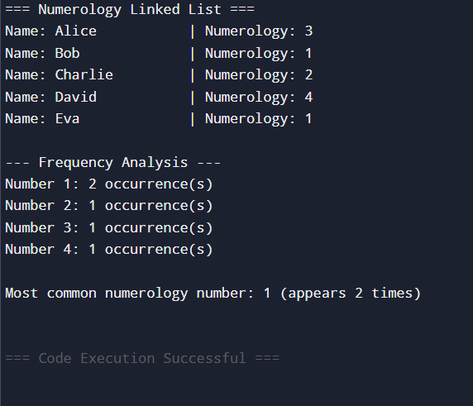

20.Create a list where students add species and their habitats, then display them grouped by pollution tolerance.
#include <stdio.h>
#include <stdlib.h>
#include <string.h>

// Node structure
typedef struct Node {
char species[50];
char habitat[50];
char tolerance[20]; // Pollution tolerance: High, Medium, Low
struct Node* next;
} Node;

// Function to create a new node
Node* createNode(const char* species, const char* habitat, const char* tolerance) {
Node* newNode = (Node*) malloc(sizeof(Node));
if (!newNode) {
printf("Memory allocation failed!\n");
exit(1);
}
strcpy(newNode->species, species);
strcpy(newNode->habitat, habitat);
strcpy(newNode->tolerance, tolerance);
newNode->next = NULL;
return newNode;
}

// Insert at end
void insertAtEnd(Node** head, const char* species, const char* habitat, const char* tolerance) {
Node* newNode = createNode(species, habitat, tolerance);
if (*head == NULL) {
*head = newNode;
return;
}
Node* temp = *head;
while (temp->next != NULL)
temp = temp->next;
temp->next = newNode;
}

// Display grouped by pollution tolerance
void displayGrouped(Node* head) {
printf("\n=== Species Grouped by Pollution Tolerance ===\n");

char* categories[] = {"High", "Medium", "Low"};
for (int i = 0; i < 3; i++) {
printf("\n%s Tolerance:\n", categories[i]);
Node* temp = head;
int found = 0;
while (temp != NULL) {
if (strcmp(temp->tolerance, categories[i]) == 0) {
printf(" Species: %-15s | Habitat: %s\n", temp->species, temp->habitat);
found = 1;
}
temp = temp->next;
}
if (!found) {
printf(" None\n");
}
}
}

// Analyse frequency of tolerance categories
void analyseFrequency(Node* head) {
int high=0, medium=0, low=0;
Node* temp = head;
while (temp != NULL) {
if (strcmp(temp->tolerance, "High") == 0) high++;
else if (strcmp(temp->tolerance, "Medium") == 0) medium++;
else if (strcmp(temp->tolerance, "Low") == 0) low++;
temp = temp->next;
}

printf("\n=== Frequency Analysis ===\n");
printf("High tolerance species: %d\n", high);
printf("Medium tolerance species: %d\n", medium);
printf("Low tolerance species: %d\n", low);
}

int main() {
Node* head = NULL;

// Sample data (students can add more dynamically)
insertAtEnd(&head, "Tilapia", "Freshwater Lakes", "High");
insertAtEnd(&head, "Trout", "Mountain Streams", "Low");
insertAtEnd(&head, "Mango Tree", "Urban Parks", "Medium");
insertAtEnd(&head, "Lotus", "Ponds", "Low");
insertAtEnd(&head, "Cockroach", "Urban Areas", "High");

displayGrouped(head);
analyseFrequency(head);

return 0;
}

OUTPUT
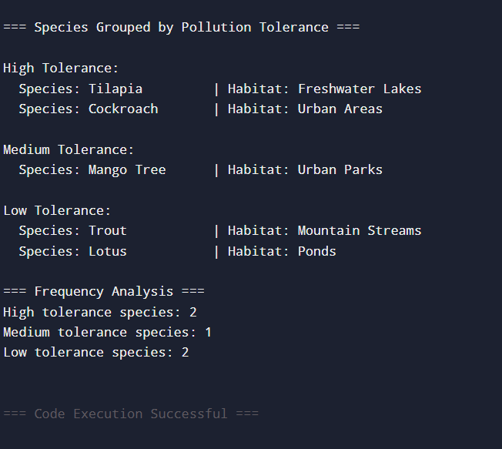

21.System to track and visualise personal health metrics (e.g., step count, calories burned, sleep).
#include <stdio.h>
#include <stdlib.h>
#include <string.h>

// Node structure for circular linked list
typedef struct Node {
char date[20];
int steps;
int calories;
int sleepHours;
struct Node* next;
} Node;

// Function to create a new node
Node* createNode(const char* date, int steps, int calories, int sleepHours) {
Node* newNode = (Node*) malloc(sizeof(Node));
if (!newNode) {
printf("Memory allocation failed!\n");
exit(1);
}
strcpy(newNode->date, date);
newNode->steps = steps;
newNode->calories = calories;
newNode->sleepHours = sleepHours;
newNode->next = newNode; // circular link to itself initially
return newNode;
}

// Insert at end in circular linked list
void insertAtEnd(Node** head, const char* date, int steps, int calories, int sleepHours) {
Node* newNode = createNode(date, steps, calories, sleepHours);
if (*head == NULL) {
*head = newNode;
return;
}
Node* temp = *head;
while (temp->next != *head) {
temp = temp->next;
}
temp->next = newNode;
newNode->next = *head;
}

// Display circular linked list
void displayList(Node* head) {
if (head == NULL) {
printf("No health data available.\n");
return;
}
Node* temp = head;
printf("\n=== Health Metrics (Circular Linked List) ===\n");
do {
printf("Date: %-10s | Steps: %-6d | Calories: %-6d | Sleep: %d hrs\n",
temp->date, temp->steps, temp->calories, temp->sleepHours);
temp = temp->next;
} while (temp != head);
}

// Analyse average metrics
void analyseMetrics(Node* head) {
if (head == NULL) return;
int totalSteps = 0, totalCalories = 0, totalSleep = 0, count = 0;
Node* temp = head;
do {
totalSteps += temp->steps;
totalCalories += temp->calories;
totalSleep += temp->sleepHours;
count++;
temp = temp->next;
} while (temp != head);

printf("\n=== Analysis ===\n");
printf("Average Steps: %d\n", totalSteps / count);
printf("Average Calories Burned: %d\n", totalCalories / count);
printf("Average Sleep Hours: %.2f\n", (float)totalSleep / count);
}

// Find day with maximum steps
void maxStepsDay(Node* head) {
if (head == NULL) return;
Node* temp = head;
int maxSteps = temp->steps;
char maxDate[20];
strcpy(maxDate, temp->date);

do {
if (temp->steps > maxSteps) {
maxSteps = temp->steps;
strcpy(maxDate, temp->date);
}
temp = temp->next;
} while (temp != head);

printf("\nDay with maximum steps: %s (%d steps)\n", maxDate, maxSteps);
}

int main() {
Node* head = NULL;

// Sample data entries
insertAtEnd(&head, "2026-04-01", 8500, 300, 7);
insertAtEnd(&head, "2026-04-02", 12000, 450, 6);
insertAtEnd(&head, "2026-04-03", 6000, 250, 8);
insertAtEnd(&head, "2026-04-04", 15000, 500, 5);

displayList(head);
analyseMetrics(head);
maxStepsDay(head);

return 0;
}
OUTPUT
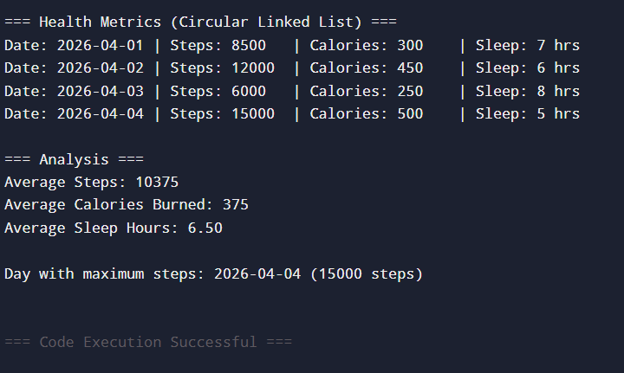

22 Design a system that organises and preserves Vedic texts in digital form, ensuring easy access to verses, rituals, and philosophical content for future generations.
#include <stdio.h>
#include <stdlib.h>
#include <string.h>

// Node structure for Vedic text entries
typedef struct Node {
char title[100];
char category[20]; // Verse, Ritual, Philosophy
char content[500]; // Text content
struct Node* next;
} Node;

// Create a new node
Node* createNode(const char* title, const char* category, const char* content) {
Node* newNode = (Node*) malloc(sizeof(Node));
if (!newNode) {
printf("Memory allocation failed!\n");
exit(1);
}
strcpy(newNode->title, title);
strcpy(newNode->category, category);
strcpy(newNode->content, content);
newNode->next = NULL;
return newNode;
}

// Insert at end
void insertAtEnd(Node** head, const char* title, const char* category, const char* content) {
Node* newNode = createNode(title, category, content);
if (*head == NULL) {
*head = newNode;
return;
}
Node* temp = *head;
while (temp->next != NULL)
temp = temp->next;
temp->next = newNode;
}

// Display grouped by category
void displayGrouped(Node* head) {
char* categories[] = {"Verse", "Ritual", "Philosophy"};
printf("\n=== Vedic Texts Organised by Category ===\n");
for (int i = 0; i < 3; i++) {
printf("\n%s:\n", categories[i]);
Node* temp = head;
int found = 0;
while (temp != NULL) {
if (strcmp(temp->category, categories[i]) == 0) {
printf(" Title: %s\n", temp->title);
printf(" Content: %s\n\n", temp->content);
found = 1;
}
temp = temp->next;
}
if (!found) {
printf(" None\n");
}
}
}

// Analyse frequency of categories
void analyseFrequency(Node* head) {
int verse=0, ritual=0, philosophy=0;
Node* temp = head;
while (temp != NULL) {
if (strcmp(temp->category, "Verse") == 0) verse++;
else if (strcmp(temp->category, "Ritual") == 0) ritual++;
else if (strcmp(temp->category, "Philosophy") == 0) philosophy++;
temp = temp->next;
}

printf("\n=== Frequency Analysis ===\n");
printf("Verses stored: %d\n", verse);
printf("Rituals stored: %d\n", ritual);
printf("Philosophical texts stored: %d\n", philosophy);
}

int main() {
Node* head = NULL;

// Sample entries (students can add more dynamically)
insertAtEnd(&head, "Gayatri Mantra", "Verse", "Om Bhur Bhuvah Svaha...");
insertAtEnd(&head, "Agnihotra Ritual", "Ritual", "Daily fire offering at sunrise and sunset.");
insertAtEnd(&head, "Advaita Philosophy", "Philosophy", "Non-duality: Atman is Brahman.");

displayGrouped(head);
analyseFrequency(head);

return 0;
}

OUTPUT
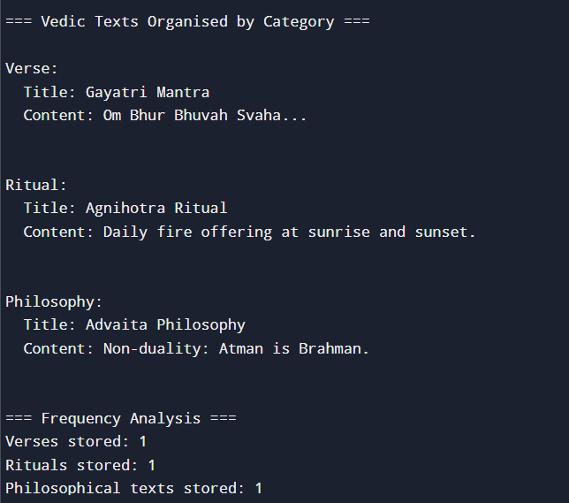

23 System that identifies and classifies common suffixes in Sanskrit words, which is essential for understanding word formation and grammar.
#include <stdio.h>
#include <stdlib.h>
#include <string.h>

// Node structure for Sanskrit words
typedef struct Node {
char word[50];
char suffix[20];
struct Node* next;
} Node;

// Create a new node
Node* createNode(const char* word, const char* suffix) {
Node* newNode = (Node*) malloc(sizeof(Node));
if (!newNode) {
printf("Memory allocation failed!\n");
exit(1);
}
strcpy(newNode->word, word);
strcpy(newNode->suffix, suffix);
newNode->next = NULL;
return newNode;
}

// Insert at end
void insertAtEnd(Node** head, const char* word, const char* suffix) {
Node* newNode = createNode(word, suffix);
if (*head == NULL) {
*head = newNode;
return;
}
Node* temp = *head;
while (temp->next != NULL)
temp = temp->next;
temp->next = newNode;
}

// Identify suffix from word (basic examples)
const char* identifySuffix(const char* word) {
int len = strlen(word);
if (len >= 3 && strcmp(&word[len-3], "aya") == 0) return "aya";
if (len >= 2 && strcmp(&word[len-2], "am") == 0) return "am";
if (len >= 2 && strcmp(&word[len-2], "ah") == 0) return "ah";
if (len >= 2 && strcmp(&word[len-2], "ti") == 0) return "ti";
if (len >= 3 && strcmp(&word[len-3], "ana") == 0) return "ana";
return "none";
}

// Display grouped by suffix
void displayGrouped(Node* head) {
printf("\n=== Sanskrit Words Grouped by Suffix ===\n");
Node* temp = head;
while (temp != NULL) {
printf("Word: %-15s | Suffix: %s\n", temp->word, temp->suffix);
temp = temp->next;
}
}

// Analyse frequency of suffixes
void analyseFrequency(Node* head) {
int aya=0, am=0, ah=0, ti=0, ana=0, none=0;
Node* temp = head;
while (temp != NULL) {
if (strcmp(temp->suffix, "aya") == 0) aya++;
else if (strcmp(temp->suffix, "am") == 0) am++;
else if (strcmp(temp->suffix, "ah") == 0) ah++;
else if (strcmp(temp->suffix, "ti") == 0) ti++;
else if (strcmp(temp->suffix, "ana") == 0) ana++;
else none++;
temp = temp->next;
}

printf("\n=== Frequency Analysis of Suffixes ===\n");
printf("aya : %d\n", aya);
printf("am : %d\n", am);
printf("ah : %d\n", ah);
printf("ti : %d\n", ti);
printf("ana : %d\n", ana);
printf("none: %d\n", none);
}

int main() {
Node* head = NULL;

// Sample Sanskrit words
char* words[] = {"Ramam", "Vedah", "Bhavati", "Gayana", "Kridaya", "Shanti"};
int n = sizeof(words)/sizeof(words[0]);

for (int i = 0; i < n; i++) {
const char* suffix = identifySuffix(words[i]);
insertAtEnd(&head, words[i], suffix);
}

displayGrouped(head);
analyseFrequency(head);

return 0;
}

OUTPUT
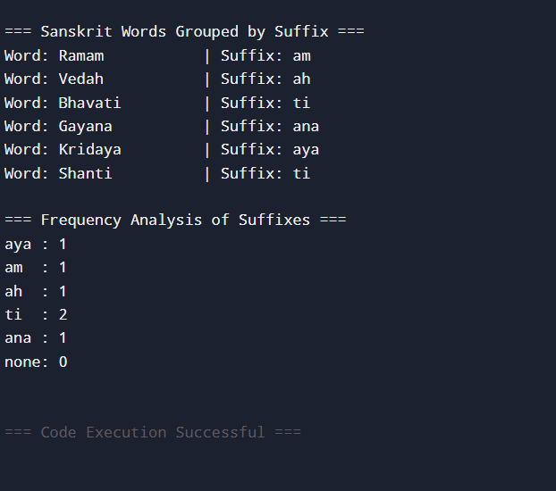

24 Case study on Improving Quality Education through Efficient Data Structures
#include <stdio.h>
#include <stdlib.h>
#include <string.h>

// Node structure for student records
typedef struct Node {
char name[50];
int gradeLevel; // L2, L3, L4, L5, L6
int attendance; // percentage
int performanceScore; // learning performance metric
struct Node* next;
} Node;

// Create a new node
Node* createNode(const char* name, int gradeLevel, int attendance, int performanceScore) {
Node* newNode = (Node*) malloc(sizeof(Node));
if (!newNode) {
printf("Memory allocation failed!\n");
exit(1);
}
strcpy(newNode->name, name);
newNode->gradeLevel = gradeLevel;
newNode->attendance = attendance;
newNode->performanceScore = performanceScore;
newNode->next = NULL;
return newNode;
}

// Insert at end
void insertAtEnd(Node** head, const char* name, int gradeLevel, int attendance, int performanceScore) {
Node* newNode = createNode(name, gradeLevel, attendance, performanceScore);
if (*head == NULL) {
*head = newNode;
return;
}
Node* temp = *head;
while (temp->next != NULL)
temp = temp->next;
temp->next = newNode;
}

// Display student records
void displayRecords(Node* head) {
printf("\n=== Student Records (Quality Education System) ===\n");
Node* temp = head;
while (temp != NULL) {
printf("Name: %-10s | Level: L%d | Attendance: %d%% | Performance: %d\n",
temp->name, temp->gradeLevel, temp->attendance, temp->performanceScore);
temp = temp->next;
}
}

// Analyse performance by grade level
void analysePerformance(Node* head) {
int total[7] = {0}, count[7] = {0};
Node* temp = head;
while (temp != NULL) {
total[temp->gradeLevel] += temp->performanceScore;
count[temp->gradeLevel]++;
temp = temp->next;
}

printf("\n=== Performance Analysis by Level ===\n");
for (int i = 2; i <= 6; i++) {
if (count[i] > 0) {
printf("L%d: Average Performance = %.2f\n", i, (float)total[i]/count[i]);
}
}
}

// Identify students needing support
void identifySupport(Node* head) {
printf("\n=== Students Needing Support (Attendance < 75%% or Performance < 50) ===\n");
Node* temp = head;
while (temp != NULL) {
if (temp->attendance < 75 || temp->performanceScore < 50) {
printf("Name: %-10s | Level: L%d | Attendance: %d%% | Performance: %d\n",
temp->name, temp->gradeLevel, temp->attendance, temp->performanceScore);
}
temp = temp->next;
}
}

int main() {
Node* head = NULL;

// Sample student data
insertAtEnd(&head, "Cloddie", 2, 80, 65);
insertAtEnd(&head, "Ronald", 3, 70, 45);
insertAtEnd(&head, "Francy", 4, 90, 75);
insertAtEnd(&head, "David", 5, 60, 40);
insertAtEnd(&head, "Teclah", 6, 85, 88);

displayRecords(head);
analysePerformance(head);
identifySupport(head);

return 0;
}

OUTPUT
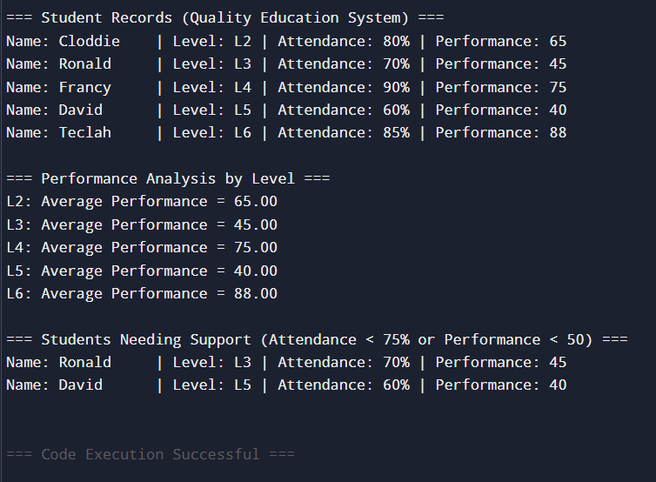

25 System that automates loan processing tasks, including loan eligibility checking, interest estimation, and repayment scheduling.
#include <stdio.h>
#include <stdlib.h>
#include <string.h>
#include <math.h> // ✅ Needed for pow()

// Node structure for loan applications
typedef struct Node {
char applicant[50];
int age;
double income;
double loanAmount;
double interestRate;
int tenureYears;
int eligible; // 1 = eligible, 0 = not eligible
struct Node* next;
} Node;

// Create a new node
Node* createNode(const char* applicant, int age, double income, double loanAmount, int tenureYears) {
Node* newNode = (Node*) malloc(sizeof(Node));
if (!newNode) {
printf("Memory allocation failed!\n");
exit(1);
}
strcpy(newNode->applicant, applicant);
newNode->age = age;
newNode->income = income;
newNode->loanAmount = loanAmount;
newNode->tenureYears = tenureYears;
newNode->interestRate = 0.0;
newNode->eligible = 0;
newNode->next = NULL;
return newNode;
}

// Insert at end
void insertAtEnd(Node** head, const char* applicant, int age, double income, double loanAmount, int tenureYears) {
Node* newNode = createNode(applicant, age, income, loanAmount, tenureYears);
if (*head == NULL) {
*head = newNode;
return;
}
Node* temp = *head;
while (temp->next != NULL)
temp = temp->next;
temp->next = newNode;
}

// Check eligibility
void checkEligibility(Node* head) {
Node* temp = head;
while (temp != NULL) {
if (temp->age >= 21 && temp->age <= 60 && temp->income >= 20000 && temp->loanAmount <= temp->income * 20) {
temp->eligible = 1;
temp->interestRate = 8.5; // base interest rate
} else {
temp->eligible = 0;
temp->interestRate = 0.0;
}
temp = temp->next;
}
}

// Estimate repayment schedule (EMI calculation)
double calculateEMI(double principal, double rate, int years) {
double monthlyRate = rate / (12 * 100);
int months = years * 12;
return (principal * monthlyRate * pow(1 + monthlyRate, months)) / (pow(1 + monthlyRate, months) - 1);
}

// Display loan applications
void displayLoans(Node* head) {
printf("\n=== Loan Applications ===\n");
Node* temp = head;
while (temp != NULL) {
printf("Applicant: %-10s | Age: %d | Income: %.2f | Loan: %.2f | Tenure: %d yrs\n",
temp->applicant, temp->age, temp->income, temp->loanAmount, temp->tenureYears);
if (temp->eligible) {
double emi = calculateEMI(temp->loanAmount, temp->interestRate, temp->tenureYears);
printf(" Eligible: Yes | Interest Rate: %.2f%% | Monthly EMI: %.2f\n", temp->interestRate, emi);
} else {
printf(" Eligible: No\n");
}
temp = temp->next;
}
}

// Analyse overall loan data
void analyseLoans(Node* head) {
int eligibleCount = 0, totalCount = 0;
double totalLoan = 0.0;
Node* temp = head;
while (temp != NULL) {
totalCount++;
if (temp->eligible) {
eligibleCount++;
totalLoan += temp->loanAmount;
}
temp = temp->next;
}
printf("\n=== Loan Analysis ===\n");
printf("Total Applications: %d\n", totalCount);
printf("Eligible Applications: %d\n", eligibleCount);
printf("Total Approved Loan Amount: %.2f\n", totalLoan);
}

int main() {
Node* head = NULL;

// Sample loan applications
insertAtEnd(&head, "Idai", 25, 30000, 200000, 5);
insertAtEnd(&head, "Francy", 19, 15000, 100000, 3);
insertAtEnd(&head, "Teclah", 40, 50000, 600000, 10);
insertAtEnd(&head, "Sande", 55, 25000, 800000, 8);

checkEligibility(head);
displayLoans(head);
analyseLoans(head);

return 0;
}

OUTPUT
